INSTAGRAM
Instagram is among the largest-growing and the fastest-growing social media platform. It was a success from the start with more than one million users just two months after it was lunched. Instagram was created in San Francisco by some two people named Kevin Systrom and Mike Krieger. Systrom created an app called Burbn, a prototype app. This app helped people to check-in where they are on their mobile web app. Systrom decided to look for team to assist him and Mike Krieger agreed to work with him. The Burbn app being similar to other already established mobile apps, they shifted the focus to only communication and through images. They removed all the fetures from the app leaving uploading of pictures, commenting and liking. The app was renamed Instagram which implied that the people using it were sending a type of instant telegram. On 6th October, 2010 , Instagrm was launched and its growth was very fast. From few users it eventually became the top photography app gaining over 100,000 users in a week which escalated to around one million users in two months. According to Kevin Systorm, the app was developed in a span of 8 weeks. In the year 2012, the app was bought by Facebook for one billion dollars; at that time it had thirteen employees. Currently it has over six million users and still gaining more and more users each and every day. Instagram has grown into an aggregated behemoth of web content. Its new feed filled with video games scores and advertisement. Top users of Instagram are top musician celebrities and television shows celebrities.

The most followed users become primarily celebrities. For example, Rihanna the pop star. The gathering of thousands or even hundreds of followers can be a motivating force. An entrant in Pew Research on online bullying said ,“ On Instagram people tend to not come off so mean. Because all they really want is for people to like their photos. To further this goal, users pose in well-rehearsed digital self-portraits, or ‘selfies’: obsessively documented outfits, cars, vacations and landscpes and fill their photos with hashtags like #instafamous #followforfollow.”
In this essay, Instafame is examined as a variety of microcelebrity. Microcelebrity is a mentality and a collection of self – proclaimed exercise endemic in social network, where users create a profile to connect to followers and disclose their private information to have more attention and therefore increasing their online status. These practices are chased in view of attention economy, a marketing point of view that allocate value according to something’s extent to attract “eyeballs” in a media-obsessed, in a world with good access to information. Consumer brands have employed eye-catching techniques which have narrowed down to individual users who have progressively used them to rise their popularity online. Social media in some online spaces allow for people who fail to be within the norms of mass culture to be popular. For example the feminist fashion blogger and the quirky YouTube comedian Miranda who sings. Compared to social media sites like Facebook that push a self-proclamation in a fixed profile structure, Instagram supplies users with a fairly unlimited social media tool, which suggests that one is able to represent themselves using a wide range of techniques. In the past few years, Instagram has worked to assemble a billion active users and growing at a fast rate compared to other social platforms. Users spend averagely fifty three minutes per day on Instagram; It’s Impact on our daily is significant. Instagram has built sub-generes,business and careers and has caused disturbance to whole industries. There are several ways Instagram has influenced modern behaviors which deserves to be considered in one’s outreach and marketing process.
Instagram has diversified beauty standards. Instagram has received criticism on affecting the mental health of young people. Some people blame the edited and filtered images that show unrealistic expectation of beauty. But there is also the other side to this; In giving the users such a reachable platform, a more diverse view of beauty can be shared. People no longer depend on traditional media broadcasting the meaning of beauty. From Instagram users sharing their stretch marks, unfiltered pimples to increase in plus size, efforts have been made via Instagram to break beauty taboos. The diverse representations are increasing on this platform and building significant audience attraction making brands to have an eye on that.
Instagram has changed the way we travel. Instagram is a discovery for travel inspiration. By seeing pictures of most idyllic places around the world at the palm of our hands, and our travel behaviors eventually change as a result. Whether using the app to do a research on probably the best places to go before we travel or choosing a specific place because we want to take a picture perfect post , ’instagram-tourism’ is having an effect.
As claimed by Facebook, seventy percent of those who use travel related hashtags use the social media platform to share their travel plans, while sixty seven percent use Instagram to discover inspiration of new journeys. These trends are also considered in Insat- popular locations. For instance, In 2016 the longest and the highest bottom bridge was opened in china but it had to be closed thirteen days later after many tourists around the world congested the place to get a shot for the ‘gram’. The increase in Instagram-influenced travel has caused the people in tourism sector to consider their strategies.
(anzia hapa uweke page moja min 250 words)Instagram has turned flat lays into a phenomenon. Instagram has caused flat lay trend to go mainstream

How does Instagram works?
Instagram Application is available on an operating system used Apple mobile phones known is IOS devices such as iPad and iPhone, it is also available on Android mobile devices like phones and tablets from google Samsung and the rest. It can also be accessed on a web based platform such as from a computer, but users can only upload and share photos or videos from their devices.

Creating an Account on Instagram

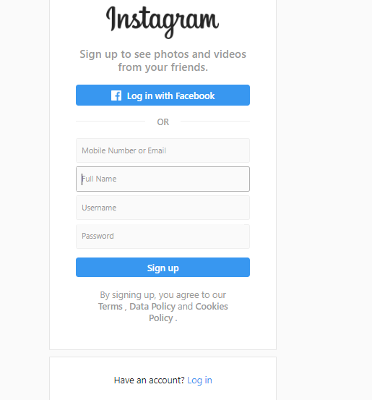
If the user is logging in to the account for the first time, he/she will be prompted to create a totally new account. The users will opt to use the signup option when the user will have to avail heir person credentials such as their mobile number or an email address, their full names, their preferred username and the account holders password. A verification message will be sent either to the account holder’s email address or a OTP message to their mobile phone. After the sign up process the Instagram account holder can now easily login by using either their phone number, email or username and then afterwards input their privacy credentials (the password) which will in turn grant them access to their own account.

How Instagram has influence the society?

Instagram can influence people to get things done, A good example is health and fitness profiles. These profiles are known to post pictures of perfectly fit bodies along with recipe ideas that have an impact on your mind and you start believing that if you eat the healthy stuff, you too could possess such a perfect body someday. This is pretty useful as many of you go on a diet and then within a few days lose interest due to lack of motivation. Instagram makes sure that you do not lose motivation as it provides your daily dosage of motivation through the effective newsfeed. Instagram has been instrumental in many body transformation cases.
Everyone Today Is a Professional Photographer
Instagram gives an opportunity to all its users worldwide to transform their amateurish pictures into something awesome. You could choose from a really broad range of filters that help to capture moments and make them truly memorable. Though you are not really a pro photographer, Instagram lets you believe so.
It's sparked new food trends
In London’s hip borough of Hackney, you’ll find Palm Vaults, a cafe which has fully grasped the benefit of providing maximum Instagram opportunity. Potted plants hang over marble tables, full of pastel-colored lattes and flower-topped granola. Its an influencer’s paradise and in attracting them, the business receives plenty of free advertising.
Other venues have followed suit, and while there are no official stats, I'd hazard a guess that the usage of neon signs, flower walls and pink plates in restaurants has risen considerably.
In general, the rule tends to be that the things that stand out succeed. Avocado on toast no longer makes the cut. Think Matcha lattes, charcoal activated croissants, acai bowls and rainbow bagels.
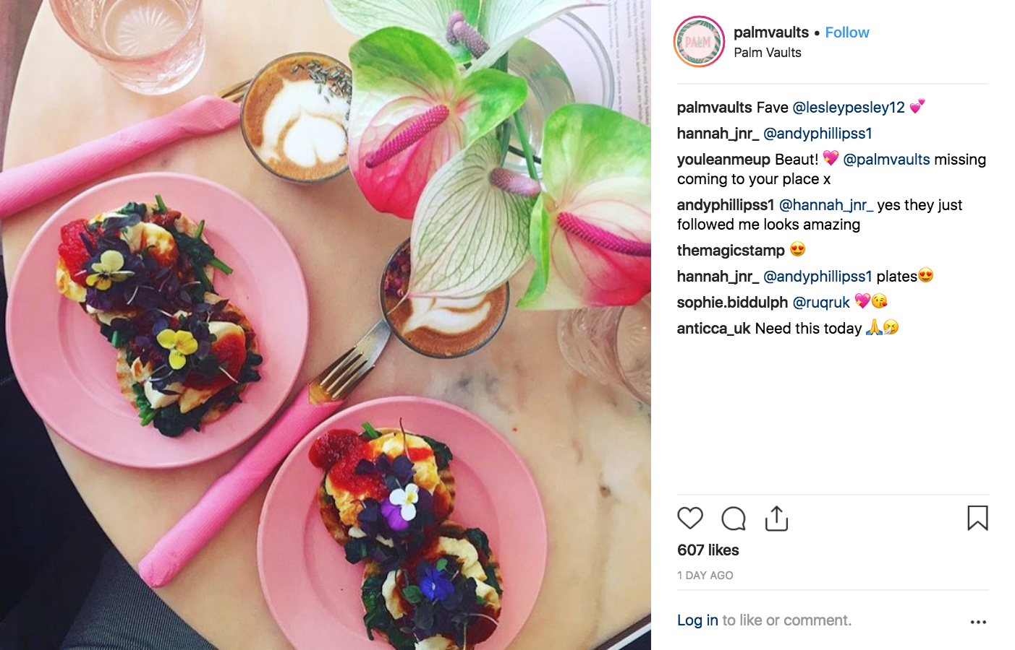

It's created entire social brands
As brands have jumped on board the Instagram marketing bandwagon, there have been some standout success stories. Some of the savviest early adopters have been able to create brands entirely on Instagram. Watch brand Daniel Wellington is a perfect example - they've used the platform to advertise their product, bypassing traditional advertising altogether. Its strategy of using its ad budget to gift watches to influencers has resulted in a flood of posts, and that hype has translated to sales, helping it become Europe’s fastest growing company between 2013 and 2015.
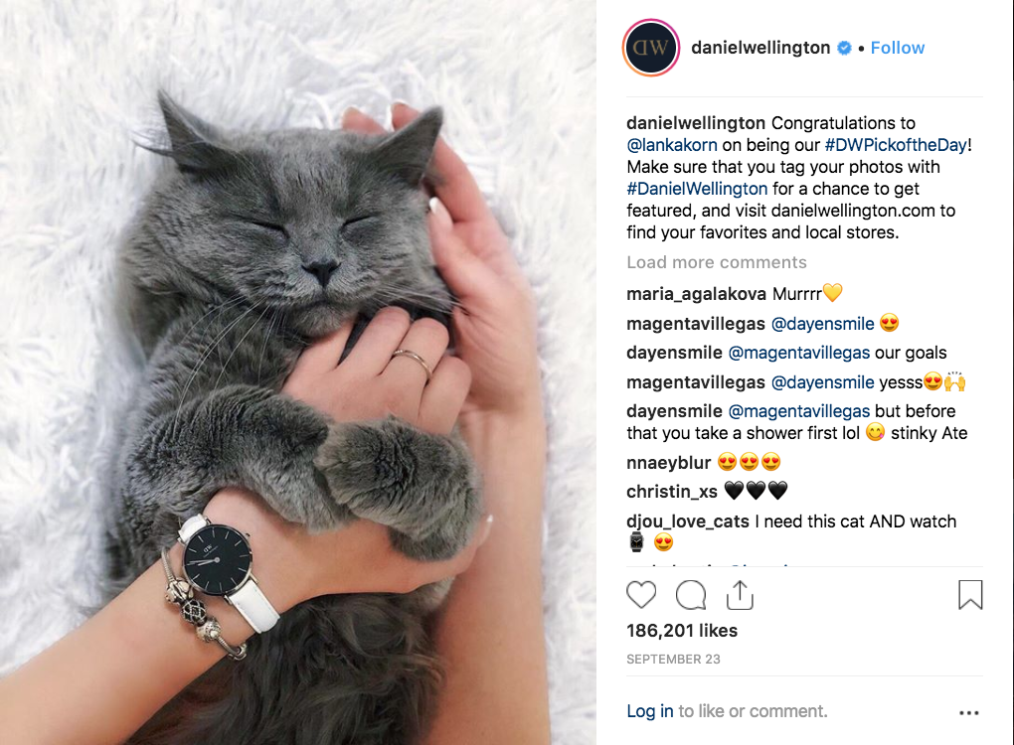

It's mobilized Activism
With an emphasis on all things visual, and direct access to millions, Instagram has also helped bring worthy causes to the fore. Imagery is incredibly powerful, and many activists now use Instagram as a storytelling device to spread their message far and wide, inspiring others to get involved. It also gives influential individuals direct access to their followers to deliver undiluted messages of support - like Justin Beiber’s Insta announcement of his support for the #blacklivesmatter movement.

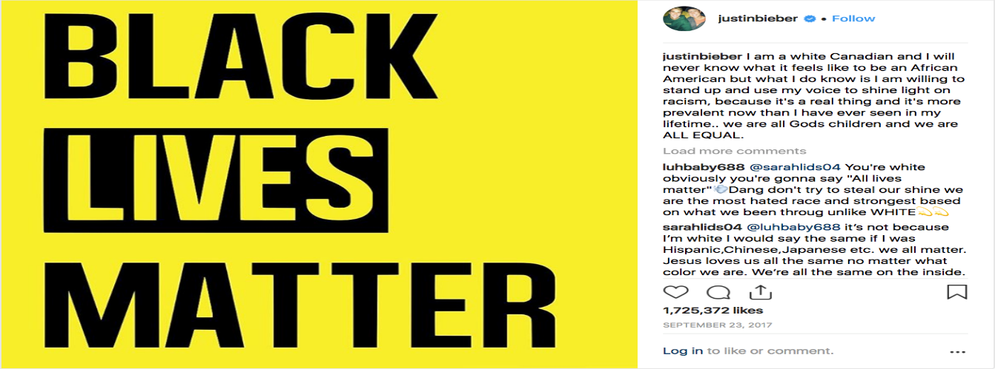

Since its inception, Instagram has proven to be a powerful communication that has impacted marketing positively for businesses. Instagram has expanded business presence and the visibility of their products to the outside world. It has also brought many users together roughly 800 million active users. Of those millions of people, over 500 million are on the platform on a daily basis. With this, there is no limit to the success of a business since it can reach it’s users through a with a dedicated Instagram strategy.

